# THE BANKING SYSTEM

Requirements Elicitation

Overview

A mock interview was conducted with the client (module lecturer) to collect information on both functional and non-functional requirements. The session was based on asking a variety of questions regarding the system. The main goal of this interview was to have a clear understanding of what the client wants as the system analyst.

Functional Requirements

The system must be able to;

* Permit a customer to open an account with a bank.
* Allow customers to open any account of their choice.
* Have a form of authentication before giving the customer any access to the system.
* Have processes that effectively include all functions relating to the opening and maintenance of accounts.
* Allow customers to make deposits in any of the accounts
* Have an automated interest calculation
* Allow withdrawal of funds
* Generate and allow viewing of transaction history

Non-functional Requirements

The system should have;

* Performance: should be fast and efficient
* Usability: should be easy to use for customers
* Security: system should be protected from unauthorized access

Structural UML Diagram

System Use Case Diagram

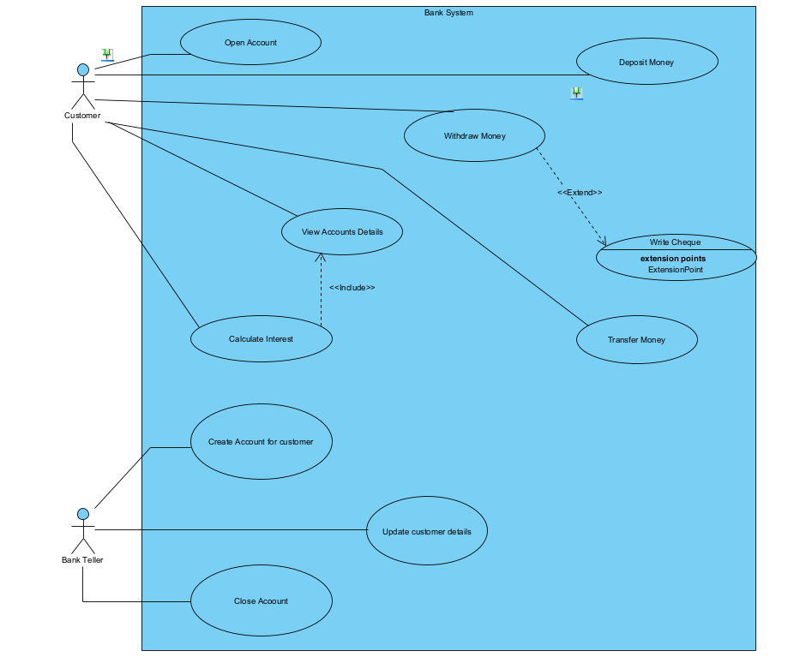

Class Diagram

Behavioural Modelling

Login Sequence Diagram

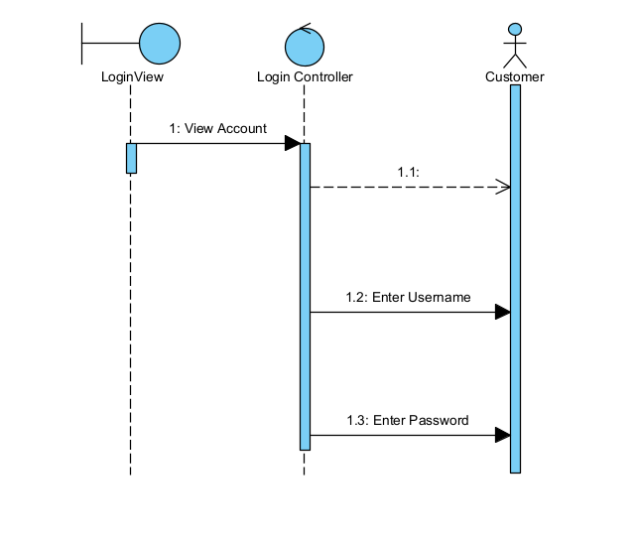

Deposit Sequence Diagram

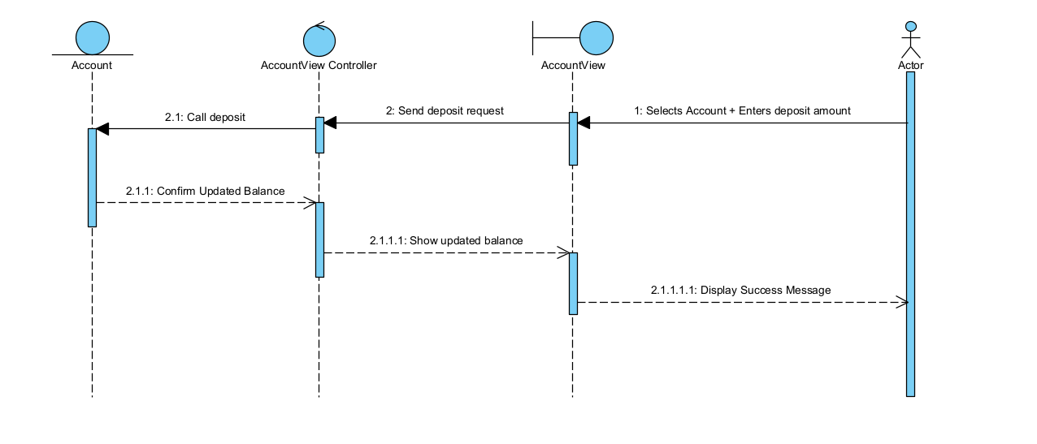

Meeting Record Appendix

Q1. Does monthly interest require huma approval or should it be fully automated?

* It should be fully automated

Q2. What customer information is critical to capture

* It should be something you can tell as a system analyst

Q3. Does system support multiple users at the same time

* Not part of the assignment

Q4. What currency should be used?

* Any that the system analyst chooses

Q5.Does the system generate any reports?

* No